We get closures because of Function and Lexical Scope

Closure is simply that combination of both, closure allows a function to access variables from an enclosing scope or environment even after it leaves the scope in which it was declared.

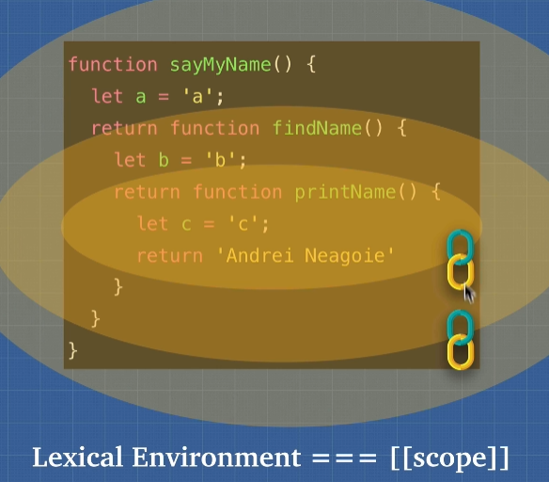

Closure and Memory

Main benefits of closure:

1. Memory efficient
2. Encapsulation